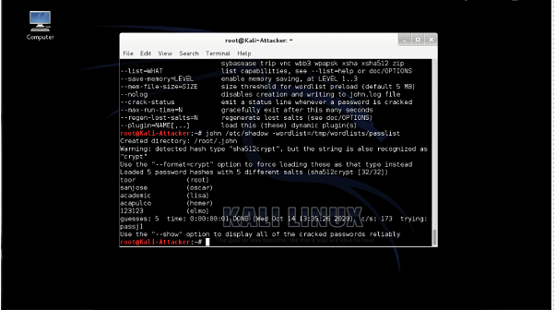

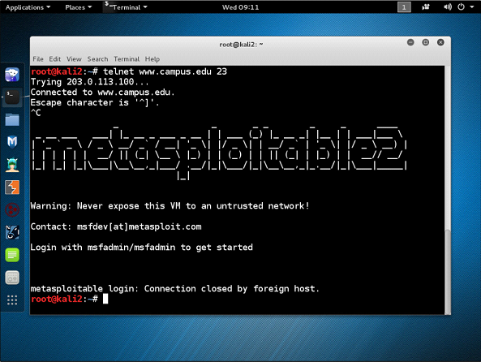

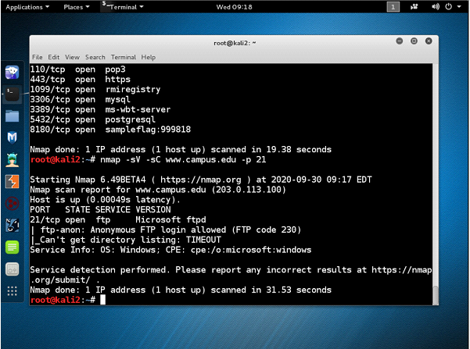

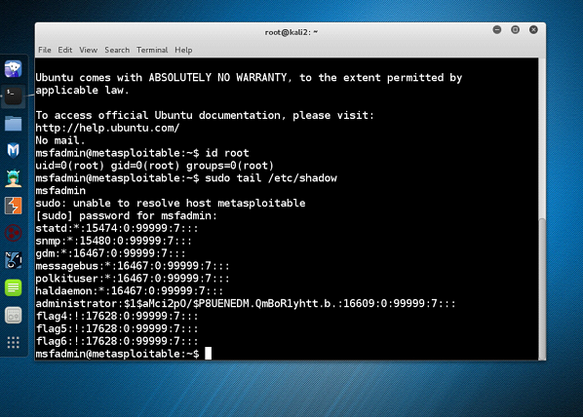

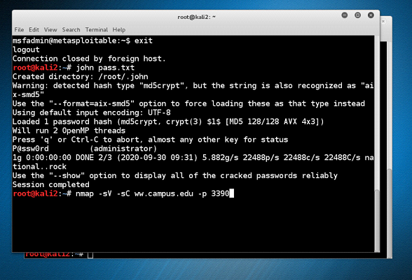

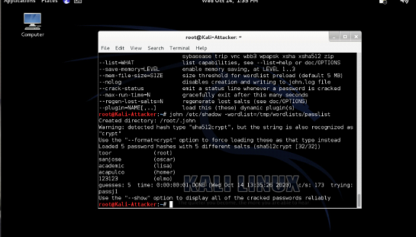

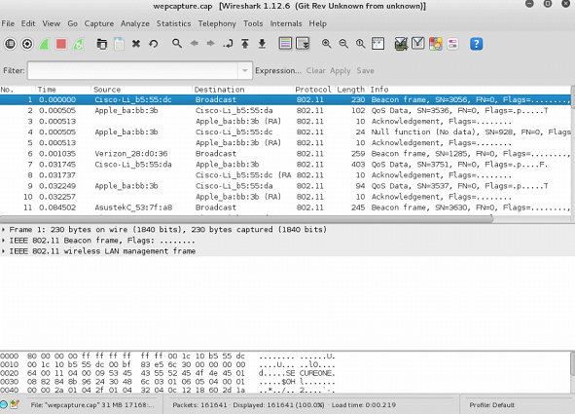

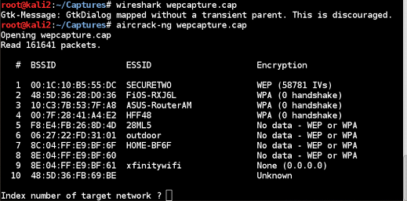

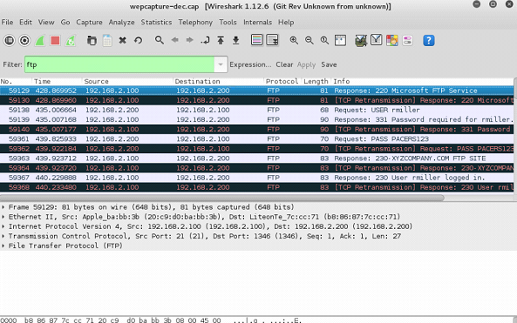

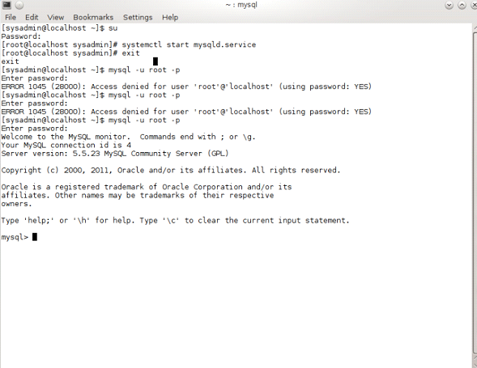

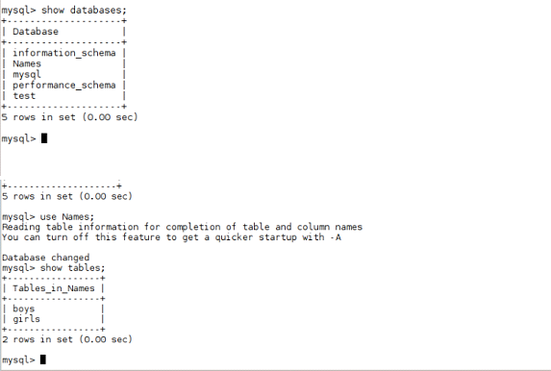

Nmap is a network scanning tool that uses IP packets to identify all the devices connected to a network and to provide information on the services and operating systems they are running. SQLmap is a open source tool used in penetration testing to detect and exploit SQL injection flaws. SQL injection attacks can take control of databases that utilize SQL. John the Ripper is a password cracking tool originally produced for UNIX-based systems. It was designed to test password strength, brute force encrypted passwords. Wireshark is a packet sniffer and analysis tool. It captures network traffic on the local network and stores that data for offline analysis. Air crack –ng is a set of utilities for analyzing Wi-Fi networks for weaknesses, You can use it to monitor Wi-Fi security, capture data packets and export them to text files for additional analysis.